EC-341 Digital System Design
BS (CE)-2k21

Project Report Traffic Control System



Submitted By:
Reg. No. | Name
21-CE-009 | Huzaifa Shahbaz
21-CE-021 | Yawar Ali Malik
21-CE-020 | Muhammad Ibtheasm

Department of Computer Engineering
HITEC University Taxila
Engr.
Fasih Ahmed

Traffic Control System
Contents
Tables of Figures: 3
Chapter#1 Abstract 5
1.1 Abstract: 5
Chapter#2 Introduction 6
2.1 Introduction: 6
Chapter#3 Objectives 6
3.1 Objectives: 6
3.1.1 Sequential Progression: 6
3.1.2 System Reset: 6
3.1.3 Lane-Specific Timing: 6
3.1.4 Clerance Periods: 6
3.1.5 Timed Delays: 6
Chapter#4 Problem Statement 6
4.1 Problem Statement: 6
Chapter#5 Expected Outcome 7
5.1 Expected Outcome: 7
Chapter#6 Components Used 7
6.1 Components Used: 7
Chapter#7 Project Diagram 8
7.1 Project Diagram: 8
Chapter#8 Truth Table of traffic control system 8
8.1 Truth Table of traffic control system: 8
Chapter#9 State Transition Table 9
9.1 State Transition Table: 9
Chapter#10 Block diagram 10
10.1 Block Diagram: 10
Chapter#11 Flow chart of traffic control system 11
11.1 Flow chart of traffic control system: 11
Chapter #12 Verilog code of traffic control System 11
12.1 Mealy machine Verilog code: 11
Chapter#13 Stimulation Waveform 15
13.1 Stimulation Waveform of Mealy machine of traffic control system: 15

Traffic Control System

Tables of Figures:
Figure 7.1:Project diagram of traffic control Systems 7
Figure 9.2:Moore machine state transition diagram of traffic control system 8
Figure 9.3:Mealy machine of state transition diagram of traffic control system 9
Figure 10.4:Block diagram of traffic control system 9
Figure 11.5:Flow chart of traffic control system 10

Traffic Control System

Table 8.1:Truth Table of Control system 7

Traffic Control System

Chapter#1 Abstract

Abstract:
The traffic control system is designed to optimize the flow of vehicles and enhance road safety through advanced signal management and real-time monitoring. It integrates traffic sensors, cameras, and communication networks to gather data on vehicle movement and road conditions. By utilizing algorithms and artificial intelligence, the system dynamically adjusts traffic signals to reduce congestion and improve traffic efficiency. Additionally, it provides timely information to drivers via variable message signs and mobile applications. This system aims to minimize travel time, reduce fuel consumption, and lower the risk of accidents, contributing to a smarter and more sustainable urban infrastructure.

Chapter#2 Introduction

2.1 Introduction:
Our project aims to develop a synchronized digital traffic control system for a four-lane intersection, where each lane is equipped with an independent traffic signal. Our goal is to create an efficient mechanism to manage the flow of vehicles through the intersection. By implementing synchronous control, we aim to enhance traffic flow, minimize congestion, and improve overall intersection safety as well as traffic flow.

Chapter#3 Objectives

3.1 Objectives:
The Objectives of traffic control system following are:

3.1.1 Sequential Progression:
Traffic transitions adhere to a strict sequence.

3.1.2 System Reset:
The option to reset the system returns traffic to its initial state, halting movement until completed.

3.1.3 Lane-Specific Timing:
Each lane receives its designated green light duration.

3.1.4 Clerance Periods:
Red light intervals between transitions allow for safe clearance.

3.1.5 Timed Delays:
Traffic lights operate with specified delay times for optimal control.

Chapter#4 Problem Statement

4.1 Problem Statement:
Designing an efficient traffic control system for a four-way road interchange presents several challenges that need to be addressed. The primary objective is to develop a state machine capable of managing the flow of vehicles through the intersection while ensuring safety and efficiency. The system must adhere to specific requirements, including sequenced transitions between lanes, reset functionality for returning to the initial state, allocation of movement times for each lane, incorporation of clearance intervals between transitions, and prioritization of main roads for longer green light durations. To address these complexities, a comprehensive understanding of traffic flow dynamics and state machine design principles is essential.

Chapter#5 Expected Outcome

5.1 Expected Outcome:
The expected outcomes of the traffic control system include a significant reduction in traffic congestion and improved traffic flow efficiency. It aims to decrease average travel times and fuel consumption, contributing to lower vehicle emissions and environmental impact. Enhanced road safety is anticipated through real-time monitoring and adaptive signal control, leading to fewer accidents. The system also expects to provide better information to drivers, improving their travel experience. Overall, it seeks to create a more sustainable and efficient urban transportation network.

Chapter#6 Components Used

6.1 Components Used:
Xilinx Vivado

Chapter#7 Project Diagram

7.1 Project Diagram:
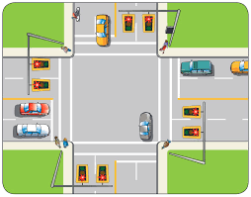
Figure 7.1:Project diagram of traffic control Systems

Chapter#8 Truth Table of traffic control system

8.1 Truth Table of traffic control system:
Table 8.1:Truth Table of Control system
Steps | A | B | Red | Yellow | Green
0 | 0 | 0 | 1 | 0 | 0
1 | 0 | 1 | 1 | 1 | 0
2 | 1 | 0 | 0 | 0 | 1
3 | 1 | 1 | 0 | 1 | 0

Chapter#9 State Transition Table

9.1 State Transition Table:
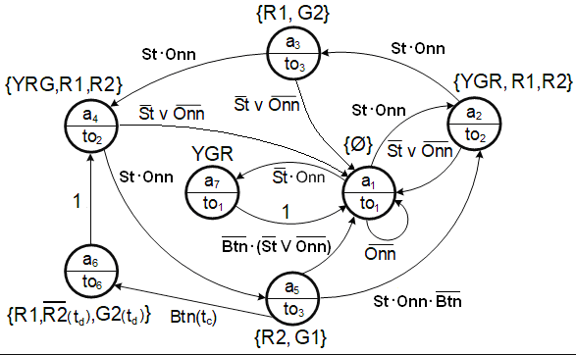
Figure 9.2:Moore machine state transition diagram of traffic control system
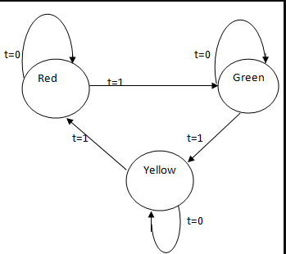
Figure 9.3:Mealy machine of state transition diagram of traffic control system

Chapter#10 Block diagram

10.1 Block Diagram:
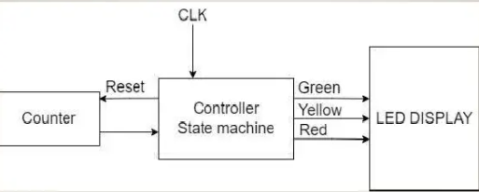
Figure 10.4:Block diagram of traffic control system

Chapter#11 Flow chart of traffic control system

11.1 Flow chart of traffic control system:
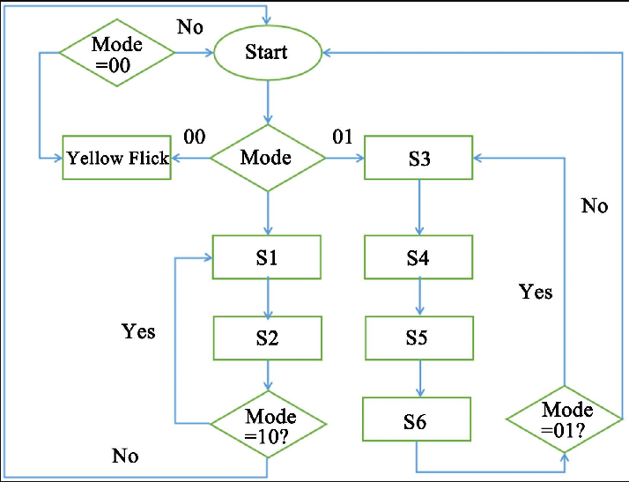
Figure 11.5:Flow chart of traffic control system

Chapter #12 Verilog code of traffic control System

12.1 Mealy machine Verilog code:
module trafficlightcontroller(
input wire clk,
input wire reset,
input wire sensor,
output reg [1:0] light
);
typedef enum reg [1:0] {
GREEN = 2'b00,
YELLOW = 2'b01,
RED = 2'b10
} state_t;

state_t current_state, next_state;

// State transition
always @(posedge clk or posedge reset) begin
if (reset) begin
current_state <= GREEN; // Default state
end else begin
current_state <= next_state;
end
end

// Next state logic and output logic
always @(*) begin
case (current_state)
GREEN: begin
light = 2'b00; // Green light
if (sensor) begin
next_state = YELLOW; // Transition to Yellow if sensor is high
end else begin
next_state = GREEN; // Stay in Green if sensor is low
end
end
YELLOW: begin
light = 2'b01; // Yellow light
next_state = RED; // Transition to Red
end
RED: begin
light = 2'b10; // Red light
if (sensor) begin
next_state = GREEN; // Transition to Green if sensor is high
end else begin
next_state = RED; // Stay in Red if sensor is low
end
end
default: begin
next_state = GREEN; // Default state
end
endcase
end
endmodule
module tbtrafficlightcontroller();
reg clk;
reg reset;
reg sensor;
wire [1:0] light;
traffic_light_controller uut (
.clk(clk),
.reset(reset),
.sensor(sensor),
.light(light)
);
initial
begin
clk = 0;
forever #5 clk = ~clk;
end
initial
begin
reset = 1;
sensor = 0;
#10 reset = 0;
#10 reset = 1;
#20 sensor = 0;
#40 sensor = 0;
#20 sensor = 1;
#10 sensor = 0;
#20 sensor = 1;
#20 sensor = 0;
#40 sensor = 0;
#50 $finish;
end
initial
begin
$monitor("Time=%0d, Reset=%b, Sensor=%b, Light=%b", $time, reset, sensor, light);
end
endmodule

Chapter#13 Stimulation Waveform

13.1 Stimulation Waveform of Mealy machine of traffic control system:

